| Cybersecurity |
| --- |
| Project 1 Technical Brief |

Make a copy of this document before you begin. Place your answers below   
each question. This completed document will be your deliverable for Project 1. Submit it through Canvas when you’re finished with the project at the end of the week.

## Your Web Application

Enter the URL for the web application that you created:

| https://abibsecurityresume.azurewebsites.net/ |
| --- |

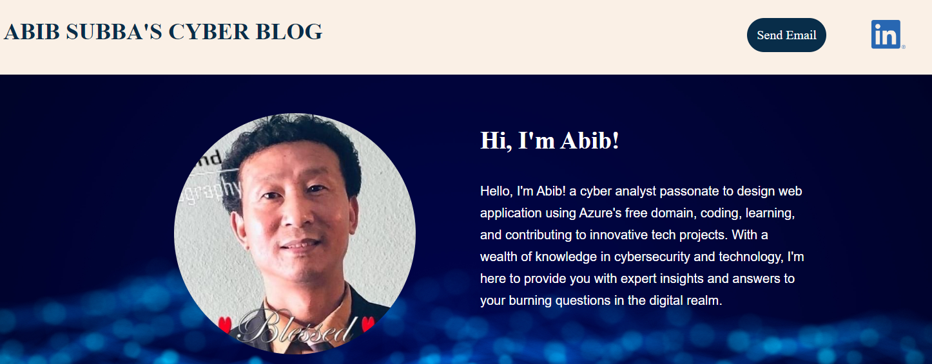

|  |
| --- |

## Day 1 Questions

### General Questions

1. What option did you select for your domain (Azure free domain, GoDaddy domain)?

| Azure free domain |
| --- |

1. What is your domain name?

| abibsecurityresume.azurewebsites.net |
| --- |

### Networking Questions

1. What is the IP address of your webpage?

| 20.48.202.168 |
| --- |

1. What is the location (city, state, country) of your IP address?

| Toronto, Ontario, Canada |
| --- |

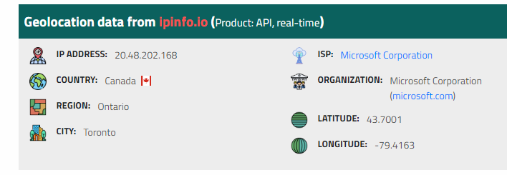

1. Run a DNS lookup on your website. What does the NS record show?

| ns1-06.azure-dns.com  Note: CP command <**nslookup -type=ns abibsecurityresume.azurewebsites.net**> |
| --- |

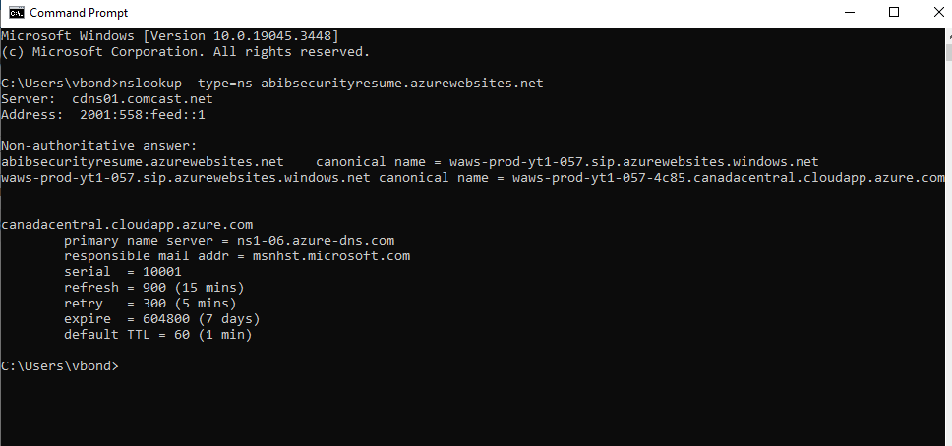

### 

### 

### 

### Web Development Questions

1. When creating your web app, you selected a runtime stack. What was it? Does it work on the front end or the back end?

| The runtime stack chosen was PHP 8.2. It works on the back end of a web application. |
| --- |

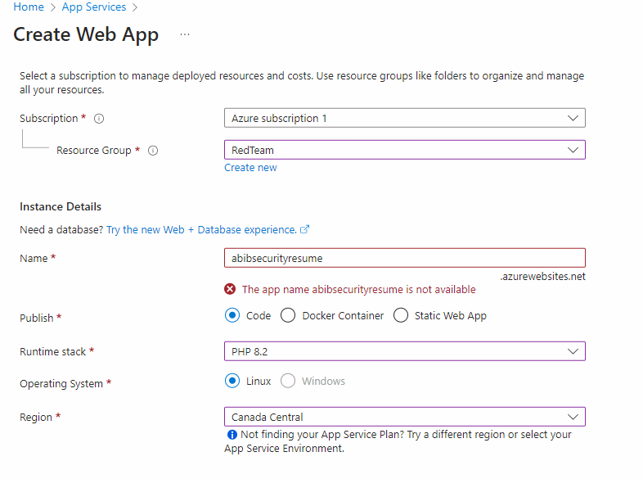

1. Inside the /var/www/html directory, there was another directory called assets. Explain what was inside that directory.

| There are 2 subdirectories named css and images.  The **css** assets are used to define styles for web pages, including the design, layout and variations in display for various devices and screen sizes. And **images** directory store images that are used by the website. |
| --- |

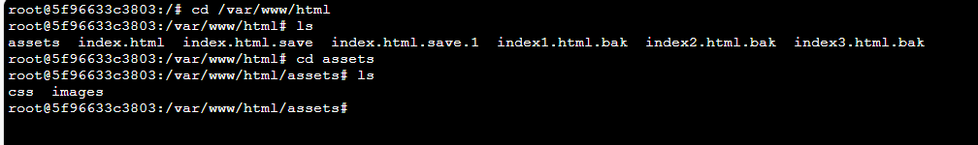

1. Consider your response to the above question. Does this work with the front end or back end?

| This works on the front end of my website. |
| --- |



## 

## 

## 

## 

## 

## Day 2 Questions

### Cloud Questions

1. What is a cloud tenant?

| It is a virtual container that utilizes cloud computing resources and services (public or private) by the customers in the cloud. Each tenant operates within its own isolated environment based on their specific needs and requirements. |
| --- |

1. Why would an access policy be important on a key vault?

| Key Vault secrets can be given access policies either by user or application to control and restrict who can access and manage cryptographic assets within a key vault, enhancing security. |
| --- |

1. Within the key vault, what are the differences between keys, secrets, and certificates?

| **Keys:** They are cryptographic keys used for encryption, decryption, and cryptographic operations to secure data at rest and in transit.  **Secrets:** They are any sensitive information that needs to be stored securely, such as passwords, connection strings, or APIs keys used for authentication and authorization purposes.  **Certificates:** They are digital documents that contain information about the identity of an entity, such as a person or organization used for securing communication through SSL/TLS protocols. |
| --- |

### Cryptography Questions

1. What are the advantages of a self-signed certificate?

| Self-signed certificates are easy to create, quick issuance, free, and cost-effective for testing but lack third-party validation. |
| --- |

1. What are the disadvantages of a self-signed certificate?

| They aren’t trusted by web browsers, causing security warnings, making them not suitable for production environments. |
| --- |

1. What is a wildcard certificate?

| A type of digital certificate that is used to secure multiple subdomains under a single domain like - “*.google.com”, “*.badssl.com”, “*.azurewebsites.net” would secure “www.example.com”, “blog.example.com”. With a wildcard certificate, a single certificate can be used to secure any number of subdomains, as long as they are all under the same root domain. |
| --- |

1. When binding a certificate to your website, Azure only provides TLS versions 1.0, 1.1, and 1.2. Explain why SSL 3.0 isn’t provided.

| SSL 3.0 is an outdated and insecure protocol due to security vulnerabilities, making it unsuitable for use in modern web applications. |
| --- |

1. After completing the Day 2 activities, view your SSL certificate and answer the following questions:
   1. Is your browser returning an error for your SSL certificate? Why or why not?

| No, the certificate on my webpage is secured from the Azure hosting site. |
| --- |

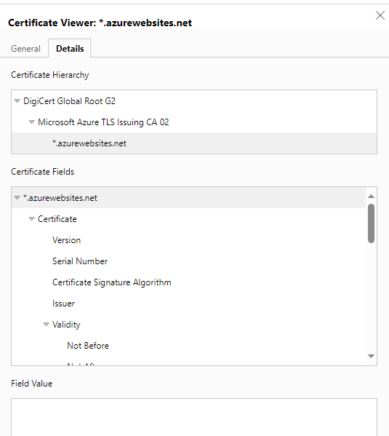

* 1. What is the validity of your certificate (date range)?

| Friday, July 21, 2023 at 3:56:12 PM to Sunday, July 20, 2025 at 3:56:12 PM. |
| --- |

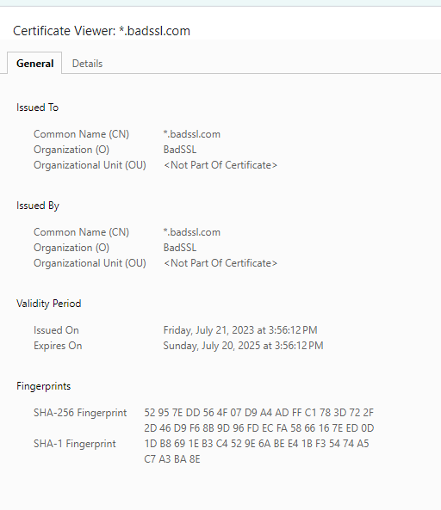

* 1. Do you have an intermediate certificate? If so, what is it?

| Yes, Microsoft Azure TLS Issuing CA 02. |
| --- |

* 1. Do you have a root certificate? If so, what is it?

| Yes, DigiCert Global Root G2 |
| --- |

* 1. Does your browser have the root certificate in its root store?

| Yes, It is GTS Root R1. |
| --- |

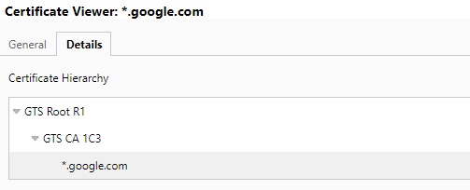

* 1. List one other root CA in your browser’s root store.

| AAA Certificate Services |
| --- |

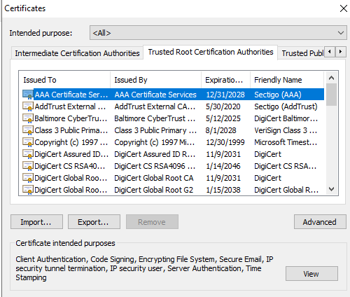

## 

## 

## 

## Day 3 Questions

### Cloud Security Questions

1. What are the similarities and differences between Azure Web Application Gateway and Azure Front Door?

| **Azure Web Application Gateway & Azure Front Door**  **Similarities:**   * Both work on the Application Layer 7 of the OSI model. * They offer Web Application Firewall (WAF) for enhanced security. * Their primary solution is a load balancer. * Both reside in front of your web application in order to protect it. * Suitable for URL path-based routing and SSL/TLS termination securing web applications within a region.   **Differences:**  **Azure Web Application Gateway** is designed specifically for web applications and provides advanced application delivery capabilities in a single region in your cloud.  **Azure Front Door** is a global, scalable, and available service that provides intelligent routing and load balancing capabilities at the DNS level in a cloud environment. |
| --- |

:

1. A feature of the Web Application Gateway and Front Door is “SSL Offloading.” What is SSL offloading? What are its benefits?

| **“SSL Offloading”** is the process of handling SSL/TLS encryption and decryption outside of web servers, typically by dedicated components like Azure Web Application Gateway or Azure Front Door.    **Benefits** are reduced server load speed time, simplified performance, enhanced security, centralized certificate management, and used as a load balancer for serving web traffic using different servers. |
| --- |

1. What OSI layer does a WAF work on?

| **Web Application Firewall** (WAF) typically operates to work at the Application Layer, which is the Layer of the OSI Layer 7. |
| --- |

1. Select one of the WAF managed rules (e.g., directory traversal, SQL injection, etc.), and define it.

| **SQL injection:** A type of Web Application attack where malicious SQL queries are injected into input fields to extract data from a database. |
| --- |

1. Consider the rule that you selected. Could your website (as it is currently designed) be impacted by this vulnerability if Front Door wasn’t enabled? Why or why not?

| Yes, it could be now and in the future. Front Door protection, as well as other security features such as DDoS protection, can help mitigate the risk of SQL injection and other web application vulnerabilities. I will never say a website is 100% secure. |
| --- |

1. Hypothetically, say that you create a custom WAF rule to block all traffic from Canada. Does that mean that anyone who resides in Canada would not be able to access your website? Why or why not?

| If I create WAF rules to block all traffic from Canada, then yes, anyone who tried to access my website from a Canadian IP address to gain access would be blocked from accessing my website. |
| --- |

1. Include screenshots below to demonstrate that your web app has the following:
   1. Azure Front Door enabled

| Azure Front Door enabled - Screenshot. |
| --- |

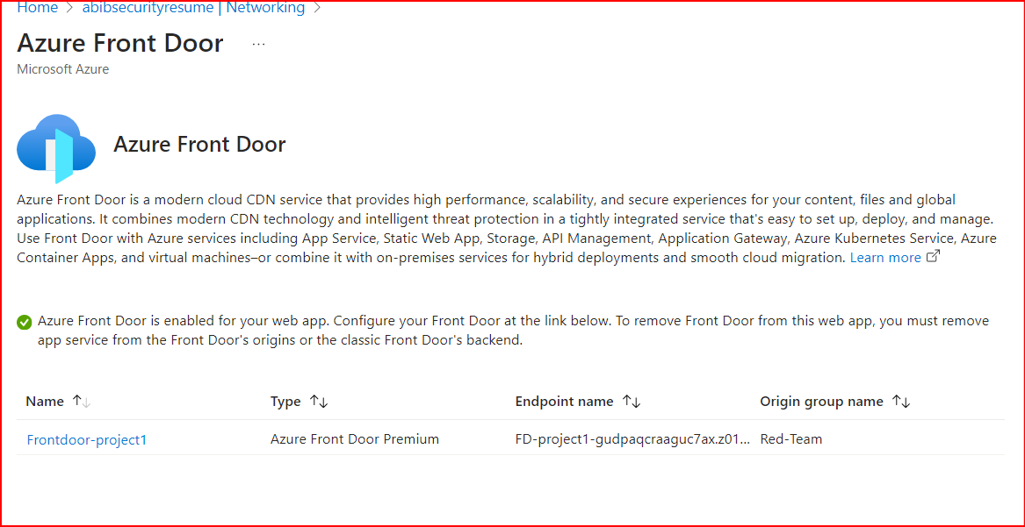

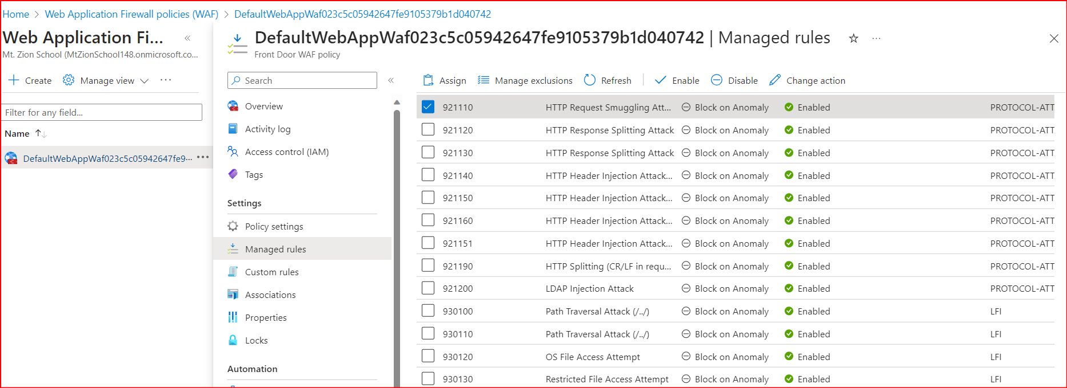

* 1. A WAF custom rule

| A WAF custom rule - Screenshot. |
| --- |

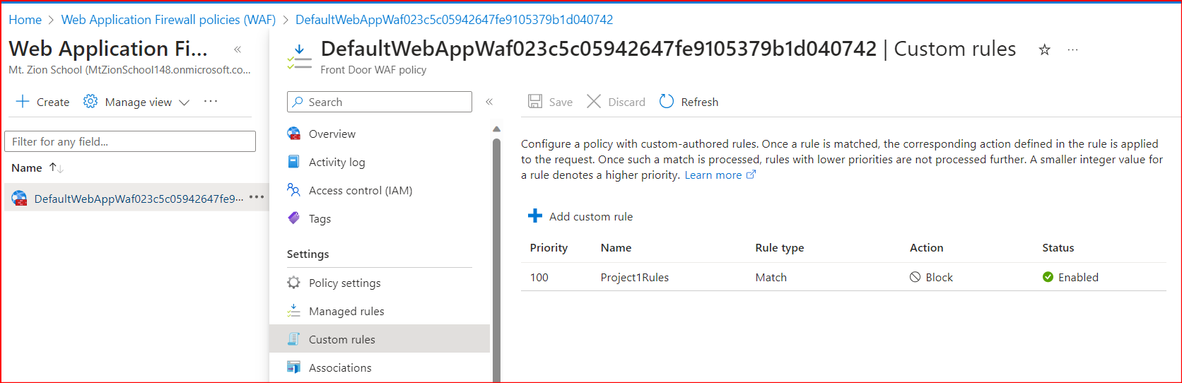

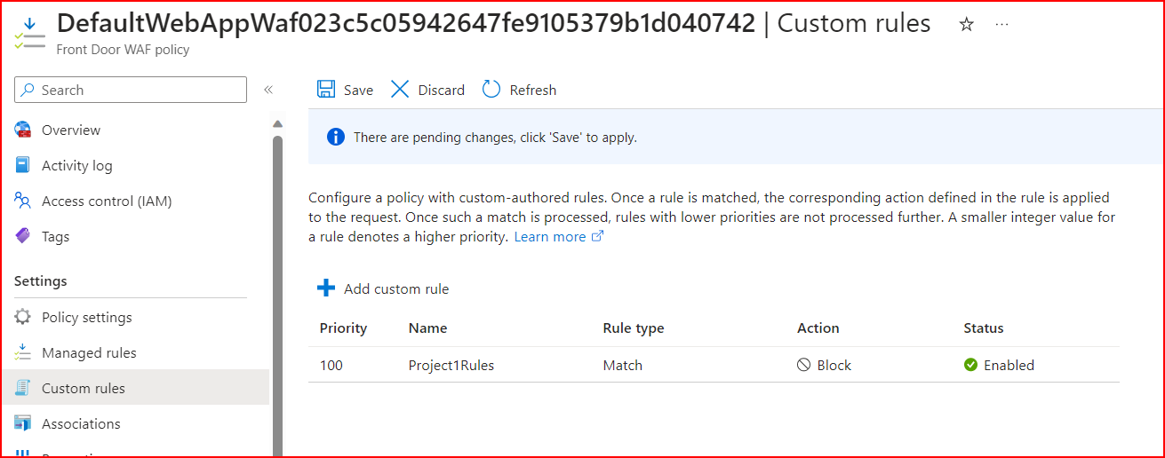

## 

## 

## Disclaimer on Future Charges

Please type “**YES**” after one of the following options:

* ***Maintaining website after project conclusion****: I am aware that I am responsible for any charges that I incur by maintaining my website. I have reviewed the* [*guidance*](https://docs.google.com/document/d/1ZzC4oTJFdlkkeWuzuJAyVSqtDFbuAWilmwXg8PZgzMs/edit) *for minimizing costs and monitoring Azure charges.*
* ***Disabling website after project conclusion****: I am aware that I am responsible for deleting all of my project resources as soon as I have gathered all of my web application screen shots and completed this document.*

***YES***

© 2022 Trilogy Education Services, a 2U, Inc. brand. All Rights Reserved.